Unique Challenges.

Experienced Support.

Parents of children recently diagnosed with an autism spectrum disorder experience unique challenges. Autism Partnership offers experienced support to help parents navigate the start of their new journey. We have developed a short term program of eight counseling sessions to address the specific needs of parents.

Our experienced counselors are uniquely qualified to provide both information regarding autism spectrum disorders and the support families need during a critical stage in their lives. We are committed to providing a place to explore the emotional and logistical challenges of raising a child on the autism spectrum.

Founded in 1994, Autism Partnership specializes in providing evidence based intervention to individuals on the autism spectrum. Each of our three directors are licensed psychologists with more than 30 years of experience in the field of autism. We are knowledgeable regarding the range of clinical issues associated with ASD and those related to loving someone with ASD.

If you are interested in services please contact Marlena Driscoll, M.A., LMFT at

mdriscoll@autismpartnership.com



**Autism Partnership**

**Counseling Services**

200 Marina Drive

Seal Beach, Ca. 90740

www.autismpartnership.com

(562) 431-9293

Short Term 8 Week Model.

Sessions are individualized to each families' needs.

Counseling for Parents

of Newly Diagnosed Children

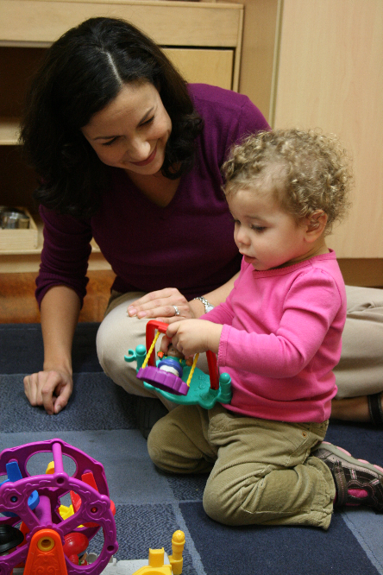

Frequently addressed topics include:

• Concerns about the future.

• What is the parent's role in treatment?

• Sharing the diagnosis with others.

• Concerns about the impact upon siblings and

the family as a whole.

• How to make treatment decisions.

• Information regarding autism through the

lifespan.

• Extended family issues.

• Stress.

• Feelings about the diagnosis.

• Accessing social supports.