We can help open discussions and inoculate against future difficulties.

Teen Relationships

and Sexuality:

A Group for Adolescents with ASD

In general dating and social relationships are complicated, add Autism Spectrum Disorder (ASD) to the mix and there is a lot to talk about. Unfortunately, individuals with ASD are at a much higher risk for relationship problems, sexual abuse and exploitation. To help protect our children Autism Partnership is introducing a group to provide education to adolescents on the spectrum regarding social/sexual issues. This group will provide adolescents a safe and engaging environment to learn about and discuss important information related to relationships, anatomy, sexual behavior, abuse, self-advocacy, personal responsibility, and marriage.

Topics Addressed Include:

• Social Relationships

• Expectations of Relationships

• Sexual Behavior: Choices, Practices, Safety,

and Guidelines

• Sex Abuse and Exploitation

• Clarifying Personal Morals and Values

• Use of Social Media

• Protecting Personal Reputation

• Risk Assessment and Reduction

If you are interested or have questions or comments please contact us at mdriscoll@autismpartnership.com.

Let's empower and prepare our teens through information.

Our group is open to both young men and women and will be facilitated by a licensed Marriage and Family Therapist. Group members will participate in discussions, exercises, and homework assignments designed to address each education goal. We provide a safe and comfortable environment to gain information while supporting parents in discussing family values and moral guidelines. Parents will have the opportunity to review the curriculum and materials prior to the start of group and will receive monthly lesson descriptions. Groups will meet once a week for an hour and half with ideally at least six members, between the ages of 14-18 participating.

Individual sessions are also available if preferred.

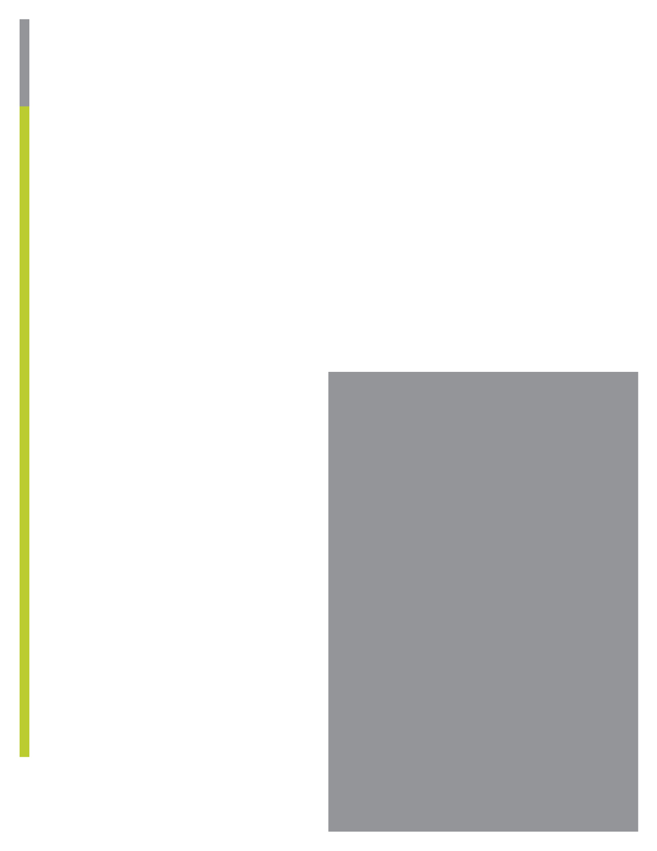

lace Logo Or

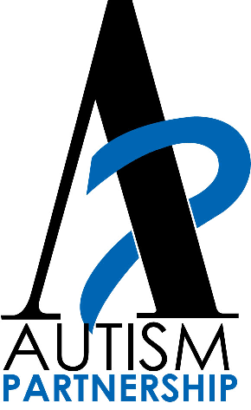

Company Name Here

**Autism Partnership**

**Counseling Services**

200 Marina Drive

Seal Beach, Ca. 90740

www.autismpartnership.com

(562) 431-9293



Insert Headline Her